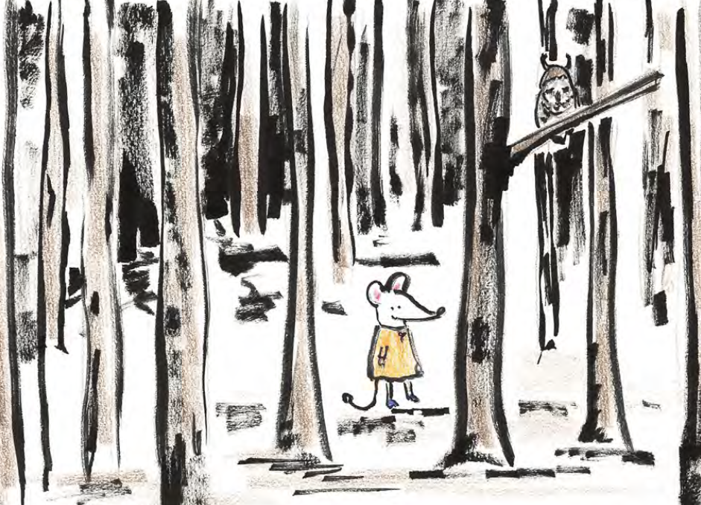
Goldilocks could see_________________________________________________
_______________________________________________________

Goldilocks could hear________________________________________________
_______________________________________________________

Goldilocks could smell_______________________________________________
_______________________________________________________

Goldilocks was feeling_______________________________________________
_______________________________________________________

