What to do
Writing
IMPORTANT Parent or Carer –
Please check that you are happy with any weblinks or use of the internet.

Our focus today is writing.

1. Discuss the organisation of lists.

Reread and enjoy Teddy’s Lists. Look again at the different lists shown in the illustrations. Look at how the lists are organised. Notice that with a list, each word is written underneath the last. Look at how Teddy has added some illustrations.

2. Write lists.

- Look at Three Lists below. Read the items together. Explain that the lists could have a title. The title tells us what each list is about. Can we say a title for each list? (You could write them too.)
- Then talk about the shopping list that Teddy made. Shopping lists are useful so that we remember what we need to buy. Make a shopping list for your next food shop and send out a designated shopper to use your child’s list (or photo of it) or use it for online shopping. You can write the list on Shopping List below and give it a title.
- Can you use the list to check that everything has been bought?

NB. Getting young children to write is not easy! See Guidance and handwriting groups below.

Try these Fun-Time Extras

- Make some lists! Take a notebook or piece of folded paper around your home or local area making lists. What is on the windowsill? What toys are on the bed? What shops are on the high street? What food does everyone want for Saturday night?

Three Lists

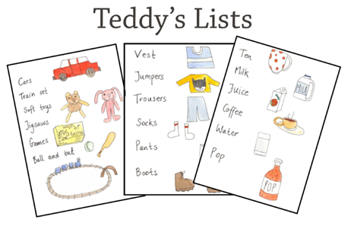
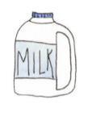
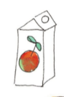
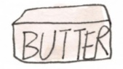
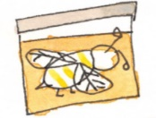
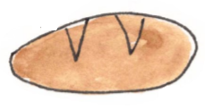
Shopping List

Guidance for writing – some dos and don’ts

- DO focus on letter formation. See sheet below. It’s really important that children get into the habit of writing letters correctly – this is not about how the finished letter looks, it’s all about how they write it – what direction they move the pencil or pen. Bad habits are almost impossible to break – if they form letters wrongly, the finished letter may look good BUT in the long run, they are much less likely to be able to write fluently.

- DON’T write a word or a line for them to copy. If they can’t remember how to write a letter, demonstrate, forming it correctly, so that they can imitate you.

- DO give loads of praise. Writing is so hard, and children get discouraged easily. It may be that they have just written one or two words, but if you praise them, it may be four words next time!

- DON’T do ‘dotty’ letters for them to trace. It is much better for children to form their own letters. We are teaching them to write not trace!

- DO write for them sometimes. It is important that young children can express their ideas in written form, and sometimes it is really good to write down what they say so that their ideas are expressed in writing on the page.

